OS/IDE specific problems and solutions

**XCode**

For anyone using Xcode on macOS — I’ve solved the duplicate keyboard input issue and the solution is stupid simple:

1 Product > Scheme > Edit Scheme (⌘<)

2 Select the Run action on the left

3 Select the Options tab

4 Under Console (at the bottom) choose: Use Terminal instead of Use Xcode

**Visual Studio**

For visual studios, when setting up the project with the project from existing code option, it will have a screen asking what kind of project you are making (not the initial screen but one of the later ones), from the drop down menu choose “windows console project” instead of the regular option.

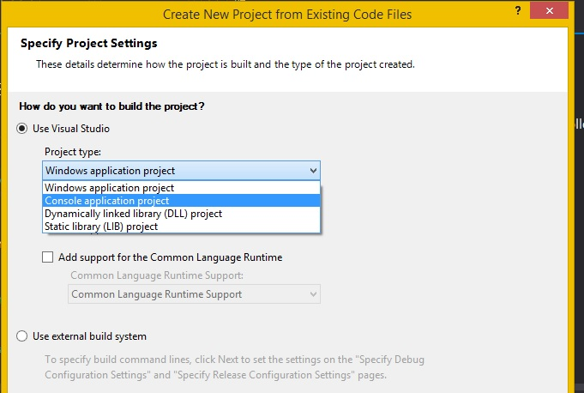

If this option did not show up or you missed it, go to PROJECT->(name of project) properties -> linker -> system and under the subsystem tab switch to console. Hit apply.

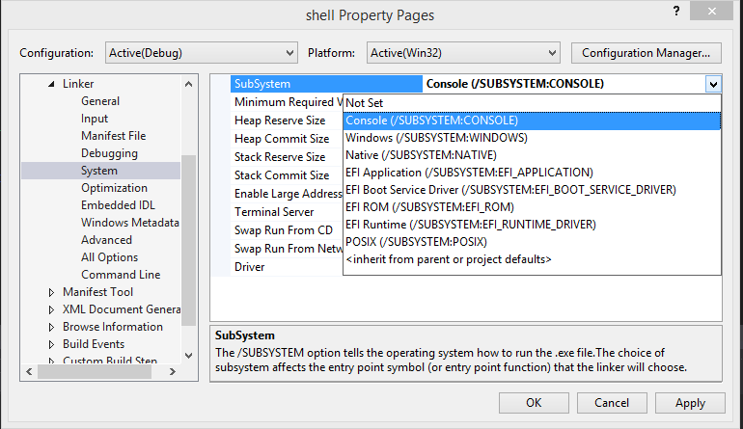

**CLion (on windows)**

If trying to use CLion on windows 10, sometimes it works, most of the time it doesn’t. If you are experiencing problems beyond this switch please switch to visual studios or use a lab machine with the linux instructions. It’s not worth the headache of trying to figure out which of the multitude of things could have gone wrong has gone wrong.

For CLion, the 'run' terminal seems to be capture keyboard input before allowing the program to see it (making it look like backspace is working but it actually isn’t). Run the exe manually from the terminal to get the intended program behavior

**CMAKE with GCC (linux/mac)**

If using CMake and GCC, if it complains about needing –fPIC or about a variable named ‘temp’ add the line in blue to your CMake file

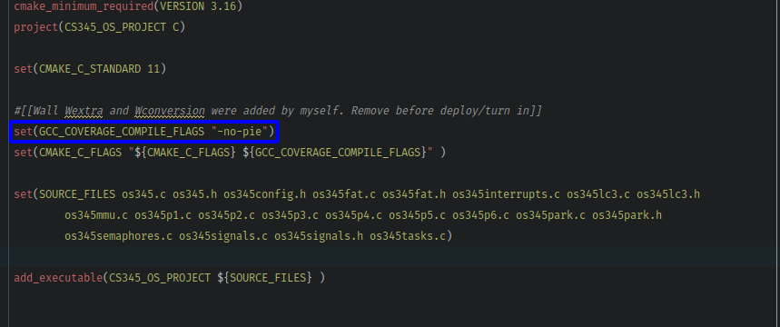

**GCC (linux)**

If using GCC not with CMake, if it complains about needing –fPIC or about a variable named ‘temp’ add the compile option ‘-no-pie’ to your command line or makefile c_flags

**Else**

If all else fails there is a makefile for linux/mac that will successfully compile your program if used correctly. It is found in the class resources tab of the class website.

For windows, install and use visual studio. It is your best bet of this lab working correctly if the others have failed.